CS 255 System Design Document Template

This template lays out all the different sections that you need to complete for Project Two. Each section has guidance to prompt your thinking. You will need to continually reference the interview transcript as you work to make sure that you are addressing your client’s needs. There is no required length for the final document. Instead the goal is to complete each section based on what your client’s needs are. Remove this note when you are finished, and replace all bracketed text with the relevant information.

UML Diagrams

UML Use Case Diagram
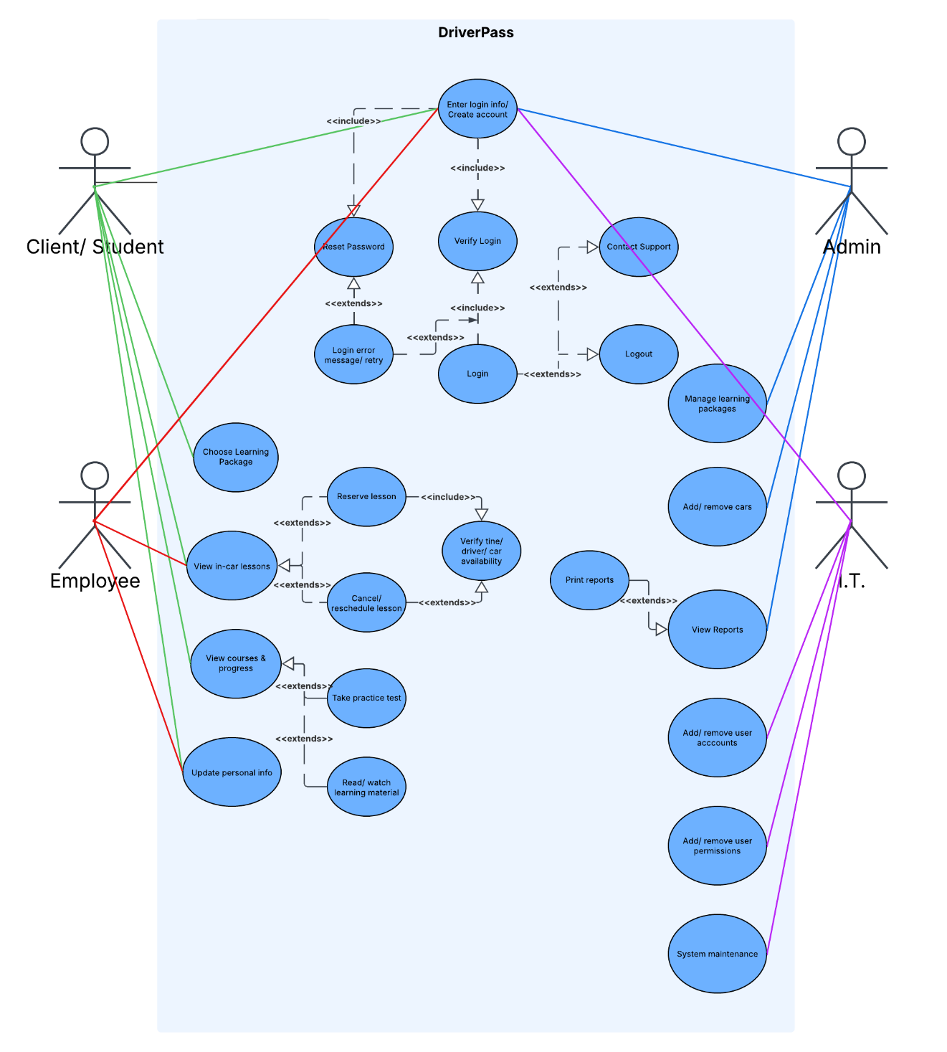

UML Activity Diagrams
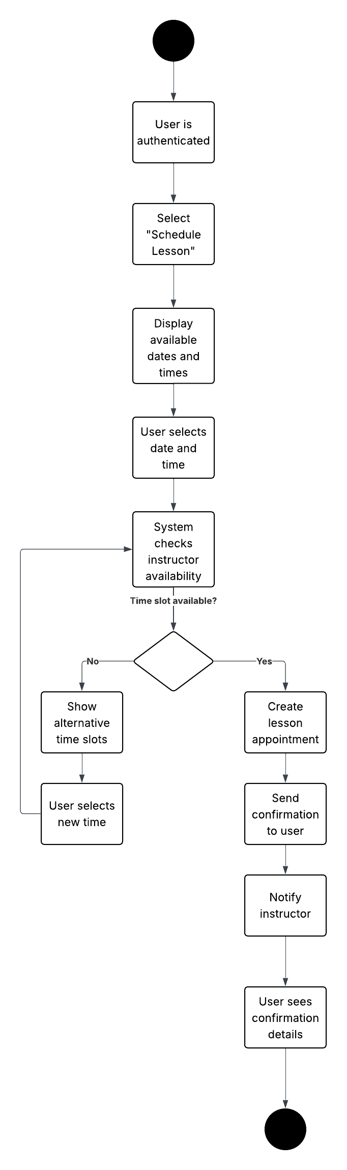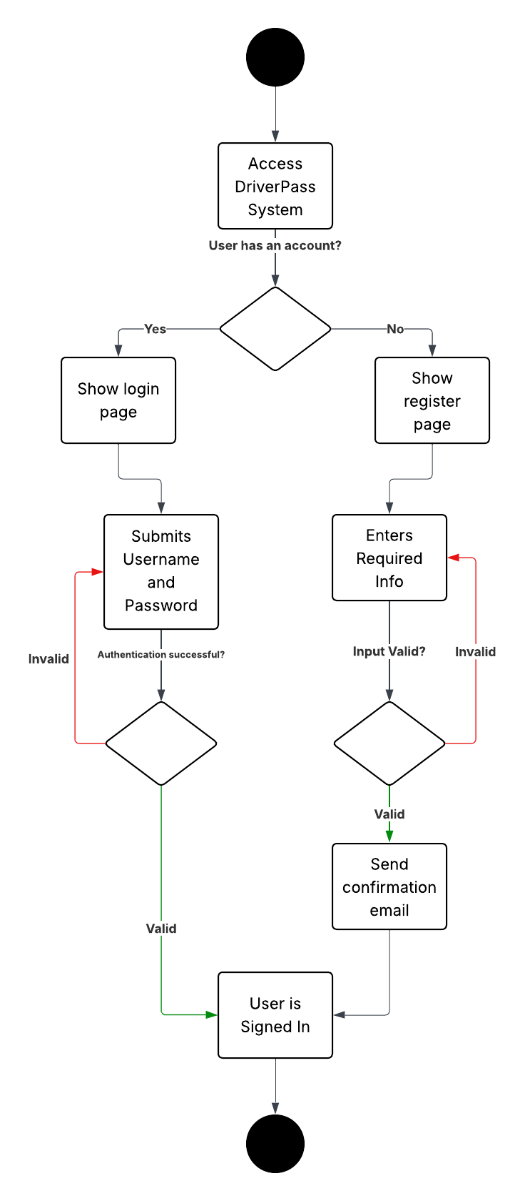

UML Sequence Diagram
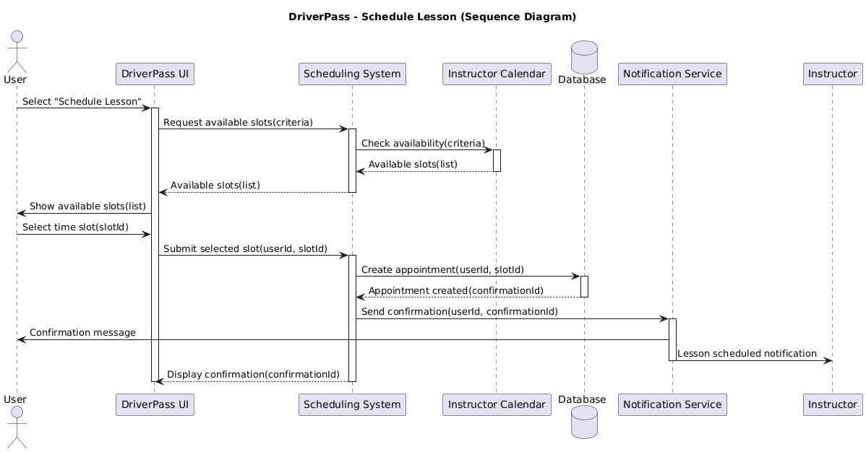

UML Class Diagram
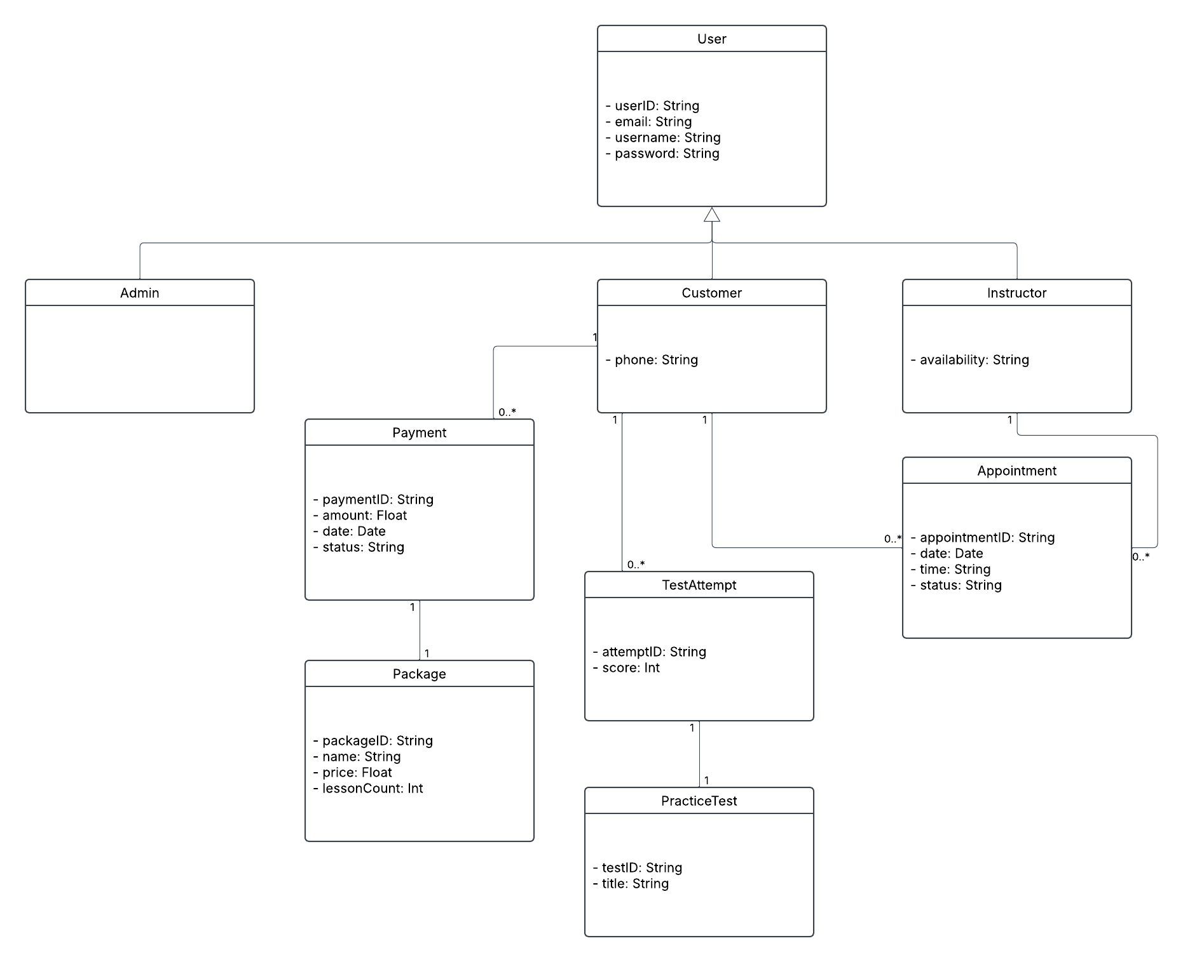

Technical Requirements
Technical Requirements
The DriverPass system will be a web-based application designed to support students, instructors, and administrators in scheduling driving lessons, managing learning materials, and processing payments. The system must meet several technical requirements related to hardware, software, tools, and infrastructure.

Hardware Requirements
The system will require standard computing devices for both users and administrators. End users (students and instructors) should be able to access the system using a personal computer, laptop, tablet, or smartphone with internet connectivity. The system will be hosted on a cloud-based server environment, which eliminates the need for on-premises hardware. The server infrastructure should support scalable processing power, memory, and storage to handle user activity, scheduling requests, and data storage.
Software Requirements
The DriverPass system will be developed as a web application using modern programming languages and frameworks. The front end will use HTML, CSS, and JavaScript to provide an interactive user interface. The back end will use a server-side language such as Java, Python, or Node.js to handle business logic, scheduling, and user authentication. A relational database management system (RDBMS), such as MySQL or PostgreSQL, will be used to store user accounts, appointments, payments, and learning materials. The system must also integrate with a third-party payment processor to securely handle transactions.

Tools and Technologies
Development of the system will require tools such as an integrated development environment (IDE), version control software (such as Git), and diagramming tools like Lucidchart for system modeling. Testing tools will be used to ensure system reliability, including unit testing and integration testing frameworks. The system will also require an email or notification service to send confirmations and alerts to users and instructors.

Infrastructure Requirements
The system will be deployed using a cloud-based infrastructure to ensure high availability, scalability, and reliability. A web server will host the application, and a database server will manage stored data. The system must support secure communication using HTTPS to protect user data. Additionally, the system should include authentication and authorization mechanisms to control access based on user roles (student, instructor, admin). Backup and recovery processes must be implemented to prevent data loss.

Security Requirements
The system must ensure the protection of sensitive user information, including login credentials and payment data. Passwords should be encrypted, and secure authentication methods should be used. The system must comply with standard security practices, including data encryption, secure API communication, and protection against unauthorized access. Integration with a trusted third-party payment processor will ensure secure handling of financial transactions.

